**Neural Network**

**Example- Fire Forest dataset**

data.frame': 517 obs. of 31 variables:

$ month : Factor w/ 12 levels "apr","aug","dec",..: 8 11 11 8 8 2 2 2 12 12 ...

$ day : Factor w/ 7 levels "fri","mon","sat",..: 1 6 3 1 4 4 2 2 6 3 ...

$ FFMC : num 86.2 90.6 90.6 91.7 89.3 92.3 92.3 91.5 91 92.5 ...

$ DMC : num 26.2 35.4 43.7 33.3 51.3 ...

$ DC : num 94.3 669.1 686.9 77.5 102.2 ...

$ ISI : num 5.1 6.7 6.7 9 9.6 14.7 8.5 10.7 7 7.1 ...

$ temp : num 8.2 18 14.6 8.3 11.4 22.2 24.1 8 13.1 22.8 ...

$ RH : int 51 33 33 97 99 29 27 86 63 40 ...

$ wind : num 6.7 0.9 1.3 4 1.8 5.4 3.1 2.2 5.4 4 ...

$ rain : num 0 0 0 0.2 0 0 0 0 0 0 ...

$ area : num 0 0 0 0 0 0 0 0 0 0 ...

$ dayfri : int 1 0 0 1 0 0 0 0 0 0 ...

$ daymon : int 0 0 0 0 0 0 1 1 0 0 ...

$ daysat : int 0 0 1 0 0 0 0 0 0 1 ...

$ daysun : int 0 0 0 0 1 1 0 0 0 0 ...

$ daythu : int 0 0 0 0 0 0 0 0 0 0 ...

$ daytue : int 0 1 0 0 0 0 0 0 1 0 ...

$ daywed : int 0 0 0 0 0 0 0 0 0 0 ...

$ monthapr : int 0 0 0 0 0 0 0 0 0 0 ...

$ monthaug : int 0 0 0 0 0 1 1 1 0 0 ...

$ monthdec : int 0 0 0 0 0 0 0 0 0 0 ...

$ monthfeb : int 0 0 0 0 0 0 0 0 0 0 ...

$ monthjan : int 0 0 0 0 0 0 0 0 0 0 ...

$ monthjul : int 0 0 0 0 0 0 0 0 0 0 ...

$ monthjun : int 0 0 0 0 0 0 0 0 0 0 ...

$ monthmar : int 1 0 0 1 1 0 0 0 0 0 ...

$ monthmay : int 0 0 0 0 0 0 0 0 0 0 ...

$ monthnov : int 0 0 0 0 0 0 0 0 0 0 ...

$ monthoct : int 0 1 1 0 0 0 0 0 0 0 ...

$ monthsep : int 0 0 0 0 0 0 0 0 1 1 ...

$ size_category: Factor w/ 2 levels "large","small": 2 2 2 2 2 2 2 2 2 2 ...

**From above data frame 3 variables are factor and remaining all are**

**numeric.**

**Our target variable area is numeric is nature.**

**Box Plot 🡺**

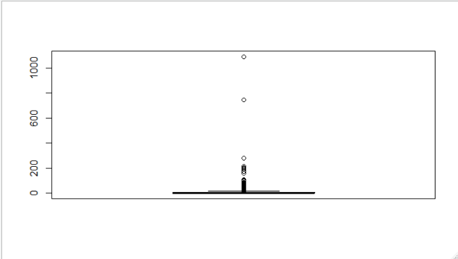

**Our target variable is area so ignoring outliers.**

**Model-1 🡺**

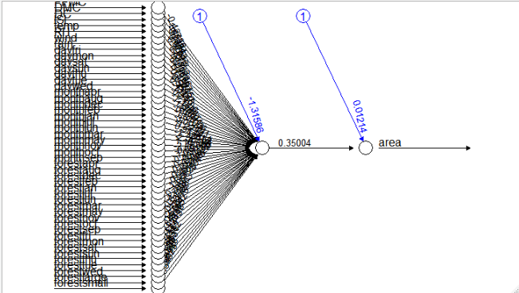

**In this model we have not considered hidden layers. We are getting**

**very low accuracy as 0.17, so we will consider hidden layers in next**

**model.**

**Model-2 🡺**

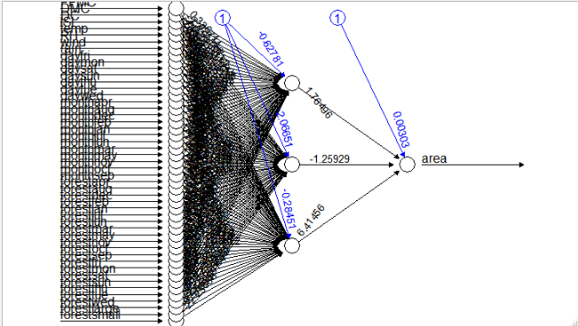

**In this model we are getting lesser accuracy as 0.13 as compared to**

**model-1.**

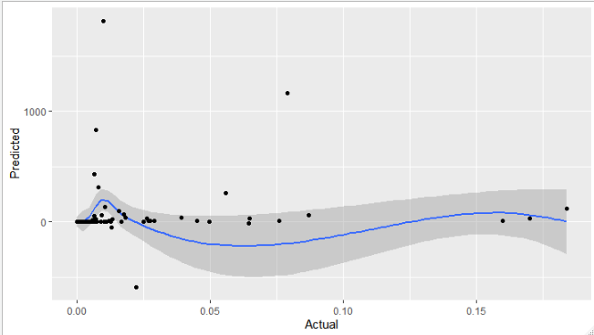

**Model-3 🡺**

**Hidden layers = 5 then again getting lesser accuracy as 0.042**

